## Reports Menu/Print Images/Pharmacist Report/4PT - RPh Corrections

Request:

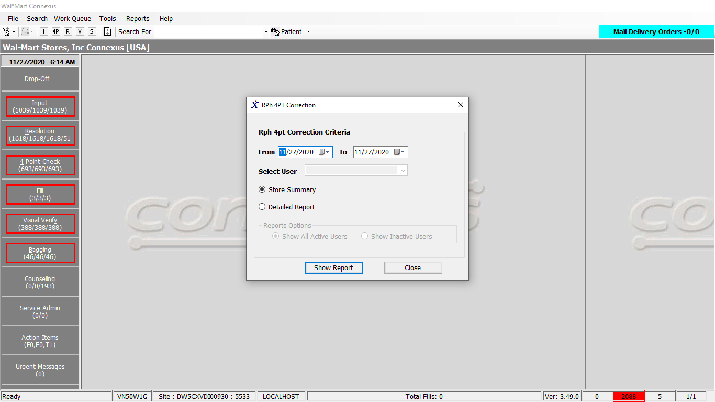

Response:

Summary report:

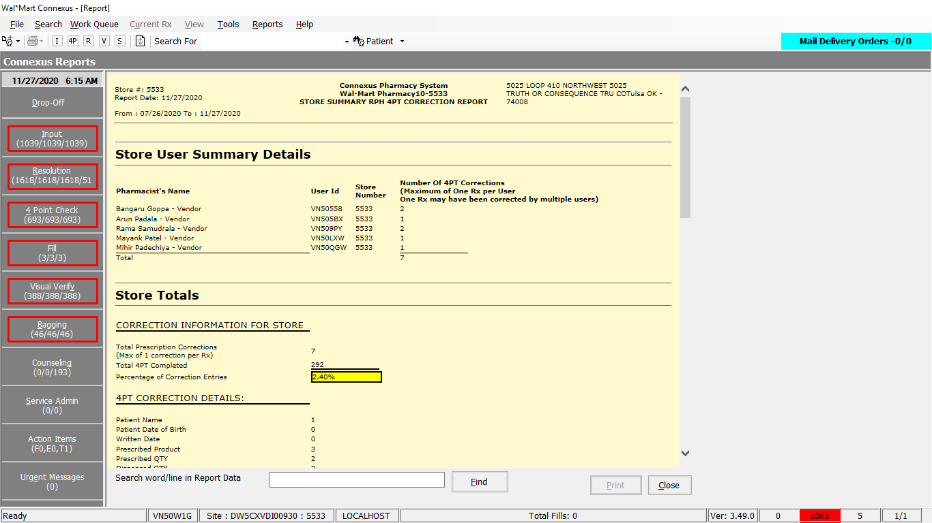

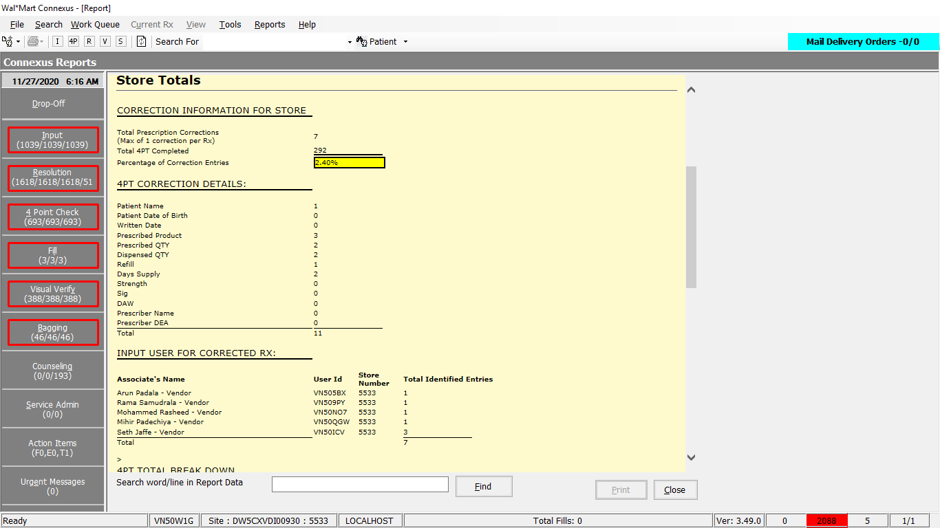

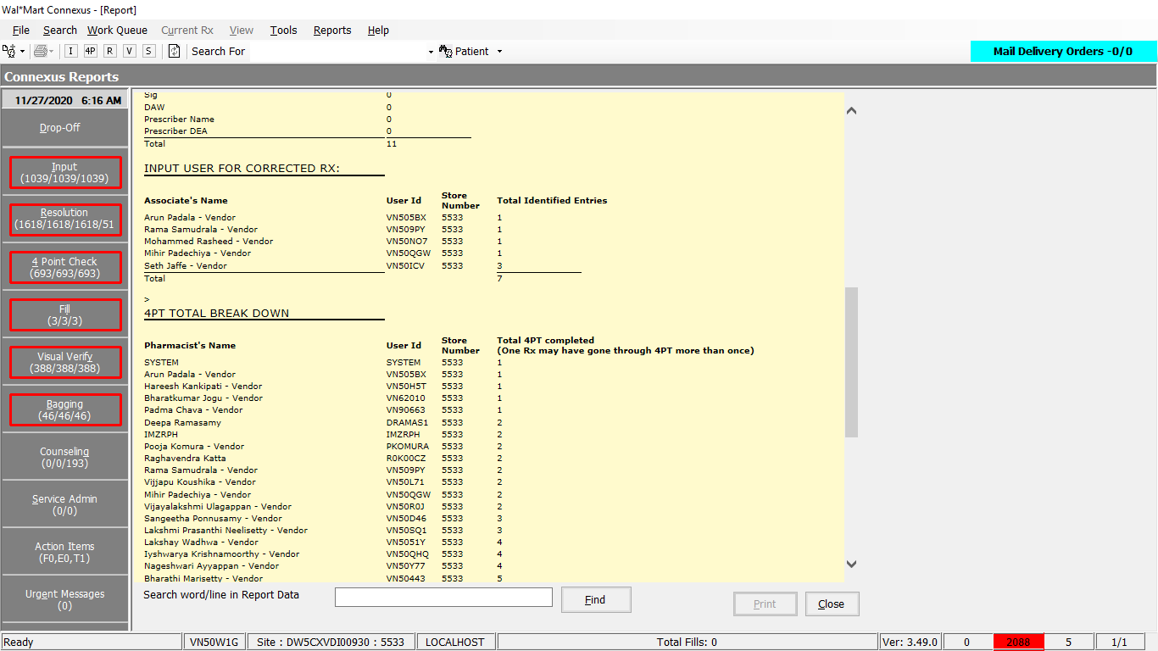

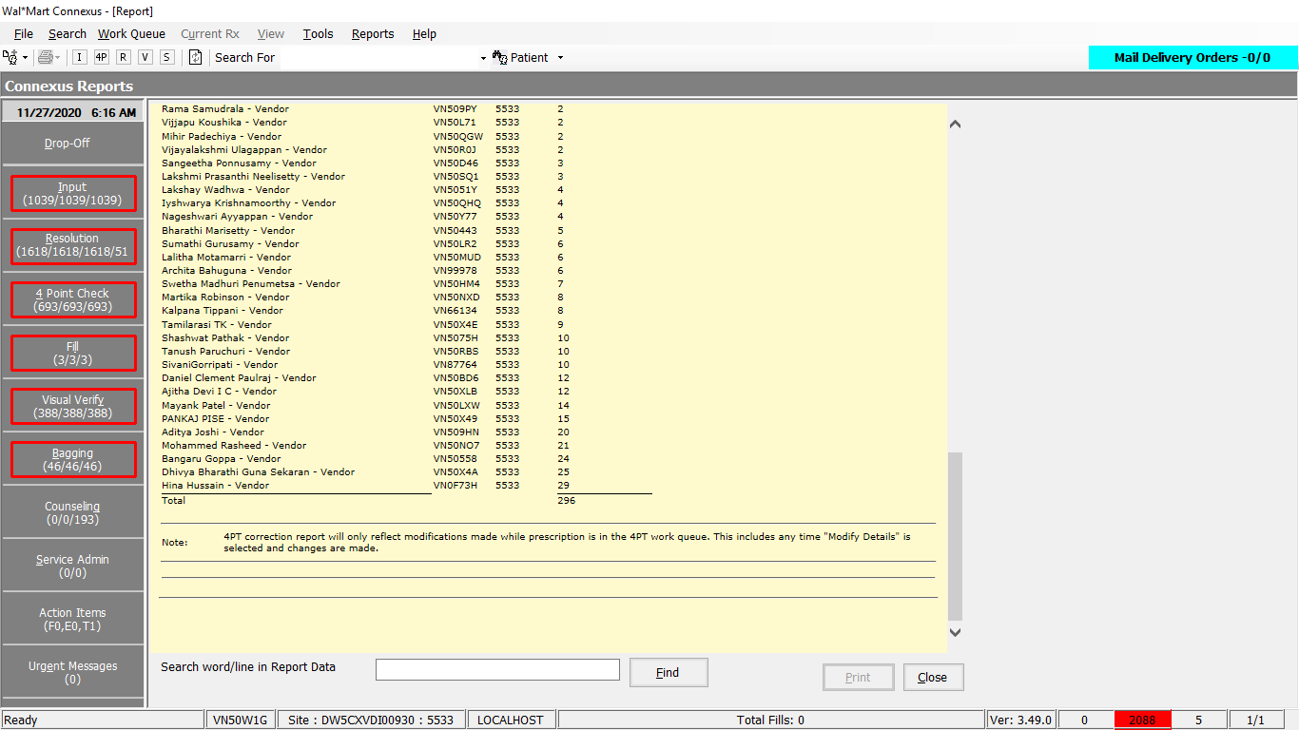

Queries:

1.Friend Const GetRPHCorrectionDetailedUserInfo As String = "SELECT rx.rx_nbr rx_nbr, EXTEND(aa.activity_ts, YEAR TO MINUTE) activity_ts, " &

" atask.task_desc task_desc, " &

" (a1.audit_userid || '.s0' || DECODE(NVL(a1.user_store_nbr, 0), 0, (SELECT phm_bu_id FROM rx21c:pharmacy_bu), a1.user_store_nbr)) error_creator" &

" FROM rx21c:rx rx, " &

" error_and_audit:appl_activity aa, " &

" error_and_audit:audit a1, " &

" error_and_audit:audit a2, " &

" error_and_audit:appl_task atask, " &

" error_and_audit:appl_actv_subject aas " &

" WHERE rx.rx_id = aas.subject_id " &

" AND aas.subject_type_code = 314 " &

" AND aas.activity_id = aa.activity_id " &

" AND aa.task_id = atask.task_id " &

" AND a1.activity_id = aa.activity_id " &

" AND a1.audit_type_code = ? " &

" AND a2.activity_id = aa.activity_id " &

" AND a2.audit_type_code = ? " &

" AND UPPER(a2.audit_userid) = UPPER(?) " &

" AND aa.class_name = ? " &

" AND DATE(aa.activity_ts) >= ? AND DATE(aa.activity_ts) <= ?"

Friend Const GetRPHCorrTotalCountsStoreByUser As String = "SELECT COUNT(UNIQUE rx.rx_nbr) total_count, '100' section_type " &

" FROM rx21c:rx rx, " &

" error_and_audit:appl_activity aa, " &

" error_and_audit:audit a3, " &

" error_and_audit:appl_actv_subject aas " &

" WHERE rx.rx_id = aas.subject_id " &

" AND aas.subject_type_code = 314 " &

" AND aas.activity_id = aa.activity_id " &

" AND a3.activity_id = aa.activity_id " &

" AND a3.audit_type_code = ? " &

" AND UPPER(a3.audit_userid) = UPPER(?) " &

" AND DATE(aa.activity_ts) >= ? AND DATE(aa.activity_ts) <= ? " &

" AND aa.class_name = ? " &

"UNION " &

"SELECT COUNT(UNIQUE ra2.rx_id) total_count, '200' type_rpt " &

" FROM rx21c:rx_activity ra2 " &

" WHERE ra2.activity_code = 1103 " &

" AND DATE(ra2.activity_ts) >= ? AND DATE(ra2.activity_ts) <= ? " &

" AND UPPER(ra2.activity_userid) = UPPER(?) "

3. Friend Const GetRPHCorrCountsByUser As String = "SELECT count(a1.audit_id) total_count, atask.task_desc task_desc, atask.task_id task_id " &

" FROM error_and_audit:appl_activity aa, " &

" error_and_audit:audit a1, " &

" error_and_audit:appl_task atask " &

" WHERE aa.task_id = atask.task_id " &

" AND a1.activity_id = aa.activity_id " &

" AND a1.audit_type_code = ? " &

" AND UPPER(a1.audit_userid) = UPPER(?) " &

" AND aa.class_name = ? " &

" AND DATE(aa.activity_ts) >= ? AND DATE(aa.activity_ts) <= ? " &

" GROUP BY 2,3 ORDER BY 2 "

4. Friend Const GetRPHCorr4ptCountsByUser As String = "SELECT COUNT(UNIQUE rx.rx_nbr) total_count, a3.audit_userid user_id, " &

" DECODE(NVL(a3.user_store_nbr, 0), 0, (SELECT phm_bu_id FROM rx21c:pharmacy_bu), a3.user_store_nbr) user_store, " &

" NVL( su.user_descr , a3.audit_userid) user_desc , " &

" '100' type_rpt " &

" FROM rx21c:rx rx, " &

" error_and_audit:appl_activity aa, " &

" error_and_audit:audit a2, " &

" error_and_audit:audit a3, " &

" error_and_audit:appl_actv_subject aas, " &

" outer(phm_appl_security:system_user su ) " &

" WHERE rx.rx_id = aas.subject_id " &

" AND aas.subject_type_code = 314 " &

" AND aas.activity_id = aa.activity_id " &

" AND a2.activity_id = aa.activity_id " &

" AND a2.audit_type_code = ? " &

" AND UPPER(a2.audit_userid) = UPPER(?) " &

" AND a3.activity_id = aa.activity_id " &

" AND a3.audit_type_code = ? " &

" AND DATE(aa.activity_ts) >= ? AND DATE(aa.activity_ts) <= ? " &

" AND aa.class_name = ? " &

" AND (DATE(su.revoke_date) >= ? OR su.revoke_date IS NULL) " &

" AND UPPER(su.userid) = UPPER(a3.audit_userid) " &

"GROUP BY 2,3,4 " &

"UNION " &

"SELECT COUNT(UNIQUE ra2.rx_id) total_count, ra2.activity_userid user_id, " &

" NVL(ra2.activity_store_nbr, (SELECT phm_bu_id FROM rx21c:pharmacy_bu)) user_store, " &

" NVL(su1.user_descr,ra2.activity_userid) user_desc, " &

" '200' type_rpt " &

" FROM rx21c:rx_activity ra2, " &

" OUTER(phm_appl_security:system_user su1) " &

" WHERE ra2.activity_code = 1103 " &

" AND UPPER(ra2.activity_userid) = UPPER(?) " &

" AND DATE(ra2.activity_ts) >= ? AND DATE(ra2.activity_ts) <= ? " &

" AND (DATE(su1.revoke_date) >= ? OR su1.revoke_date IS NULL) " &

" AND UPPER(ra2.activity_userid) = UPPER(su1.userid) " &

"GROUP BY 2,3,4 "

Friend Const GetRPHCorrTotalCountsStore As String = "SELECT COUNT(UNIQUE rx.rx_nbr) total_count, '100' section_type " &

" FROM rx21c:rx rx, " &

" error_and_audit:appl_activity aa, " &

" error_and_audit:audit a3, " &

" error_and_audit:appl_actv_subject aas " &

" WHERE rx.rx_id = aas.subject_id " &

" AND aas.subject_type_code = 314 " &

" AND aas.activity_id = aa.activity_id " &

" AND a3.activity_id = aa.activity_id " &

" AND a3.audit_type_code = ? " &

" AND DATE(aa.activity_ts) >= ? AND DATE(aa.activity_ts) <= ? " &

" AND aa.class_name = ? " &

"UNION " &

"SELECT COUNT(UNIQUE ra2.rx_id) total_count, '200' type_rpt " &

" FROM rx21c:rx_activity ra2 , rx21c:rx rx " &

" WHERE ra2.activity_code = 1103 " &

" AND DATE(ra2.activity_ts) >= ? AND DATE(ra2.activity_ts) <= ? " &

" AND ra2.rx_id = rx.rx_id "

Friend Const GetRPHCorrCounts As String = "SELECT count(a1.audit_id) total_count, atask.task_desc task_desc, atask.task_id task_id " &

" FROM error_and_audit:appl_activity aa, " &

" error_and_audit:audit a1, " &

" error_and_audit:appl_task atask " &

" WHERE aa.task_id = atask.task_id " &

" AND a1.activity_id = aa.activity_id " &

" AND a1.audit_type_code = ? " &

" AND aa.class_name = ? " &

" AND DATE(aa.activity_ts) >= ? AND DATE(aa.activity_ts) <= ? " &

" GROUP BY 2,3 ORDER BY 2 "

Friend Const GetRPHCorr4ptCounts As String = "SELECT COUNT(UNIQUE rx.rx_nbr) total_count, a3.audit_userid user_id, " &

" DECODE(NVL(a3.user_store_nbr, 0), 0, (SELECT phm_bu_id FROM rx21c:pharmacy_bu), a3.user_store_nbr) user_store, " &

" NVL( su.user_descr , a3.audit_userid) user_desc , " &

" '100' type_rpt " &

" FROM rx21c:rx rx, " &

" error_and_audit:appl_activity aa, " &

" error_and_audit:audit a3, " &

" error_and_audit:appl_actv_subject aas, " &

" outer(phm_appl_security:system_user su ) " &

" WHERE rx.rx_id = aas.subject_id " &

" AND aas.subject_type_code = 314 " &

" AND aas.activity_id = aa.activity_id " &

" AND a3.activity_id = aa.activity_id " &

" AND a3.audit_type_code = ? " &

" AND DATE(aa.activity_ts) >= ? AND DATE(aa.activity_ts) <= ? " &

" AND aa.class_name = ? " &

" AND (DATE(su.revoke_date) >= ? OR su.revoke_date IS NULL) " &

" AND UPPER(su.userid) = UPPER(a3.audit_userid) " &

"GROUP BY 2,3,4 " &

"UNION " &

"SELECT COUNT(UNIQUE ra2.rx_id) total_count, ra2.activity_userid user_id, " &

" NVL(ra2.activity_store_nbr, (SELECT phm_bu_id FROM rx21c:pharmacy_bu)) user_store, " &

" NVL(su1.user_descr,ra2.activity_userid) user_desc, " &

" '200' type_rpt " &

" FROM rx21c:rx_activity ra2, " &

" OUTER(phm_appl_security:system_user su1), " &

" rx21c:rx rx2 " &

" WHERE ra2.activity_code = 1103 " &

" AND DATE(ra2.activity_ts) >= ? AND DATE(ra2.activity_ts) <= ? " &

" AND (DATE(su1.revoke_date) >= ? OR su1.revoke_date IS NULL) " &

" AND UPPER(ra2.activity_userid) = UPPER(su1.userid) " &

s " AND ra2.rx_id = rx2.rx_id " &

"GROUP BY 2,3,4 "

Friend Const GetRPHCorrectionSummary As String = "SELECT COUNT(UNIQUE rx.rx_nbr) total_count, a1.audit_userid user_id, " &

" DECODE(NVL(a1.user_store_nbr, 0), 0, (SELECT phm_bu_id FROM rx21c:pharmacy_bu), a1.user_store_nbr) user_store, " &

" NVL(su.user_descr,a1.audit_userid) user_desc " &

" FROM error_and_audit:appl_activity aa, " &

" error_and_audit:audit a1, " &

" error_and_audit:appl_actv_subject aas, " &

" rx21c:rx rx, " &

" phm_appl_security:system_user su " &

" WHERE rx.rx_id = aas.subject_id " &

" AND su.security_level = 1 " &

" AND aas.subject_type_code = 314 " &

" AND aas.activity_id = aa.activity_id " &

" AND a1.activity_id = aa.activity_id " &

" AND a1.audit_type_code = ? " &

" AND DATE(aa.activity_ts) >= ? AND DATE(aa.activity_ts) <= ? " &

" AND aa.class_name = ? " &

" AND (DATE(su.revoke_date) >= ? OR su.revoke_date IS NULL) " &

" AND UPPER(su.userid) = UPPER(a1.audit_userid) " &

" GROUP BY 2,3,4 ORDER BY 2 "

Dal:

Public Function getRPHCorrStoreUserDetailed(ByVal siteId As Integer, ByVal BeginDate As Date, ByVal EndDate As Date, ByVal UserID As String) As List(Of RPHCorrectionDetailsBE) Implements IReportDAL.getRPHCorrStoreUserDetailed

Using (New Tracer(ConnexusCommonConstants.ConnexusTracer))

Dim response As New List(Of RPHCorrectionDetailsBE)

Dim tempStat As RPHCorrectionDetailsBE

Dim paramList As New List(Of DbParameter)

paramList.AddParameter(DbType.Int32, AuditTypeCode.Creator, "errorCreator")

paramList.AddParameter(DbType.Int32, AuditTypeCode.Resolver, "resolveUser")

paramList.AddParameter(DbType.String, UserID.ToUpper.Trim, "userID")

paramList.AddParameter(DbType.String, ServicesCommonConstants.InputError4PTErrorResolved, "ResolveStation")

paramList.AddParameter(DbType.Date, BeginDate, "startDate")

paramList.AddParameter(DbType.Date, EndDate, "endDate")

Using dr As IDataReader = ExecuteReader(DatabaseEnum.Error_And_Audit, siteId, ReportQueries.GetRPHCorrectionDetailedUserInfo, paramList)

While dr.Read()

tempStat = New RPHCorrectionDetailsBE

tempStat.RxNumber = dr.GetValueOrDefault(Of Int32)("rx_nbr")

tempStat.TimeStamp = dr.GetValueOrDefault(Of DateTime)("activity_ts")

tempStat.EntryTypeDesc = dr.GetValueOrDefault(Of String)("task_desc")

tempStat.InputUser = dr.GetValueOrDefault(Of String)("error_creator")

response.Add(tempStat)

End While

End Using

Return response

End Using

End Function

Public Function getRPHCorrStoreUserDetailed(ByVal siteId As Integer, ByVal BeginDate As Date, ByVal EndDate As Date, ByVal UserID As String) As List(Of RPHCorrectionDetailsBE) Implements IReportDAL.getRPHCorrStoreUserDetailed

Using (New Tracer(ConnexusCommonConstants.ConnexusTracer))

Dim response As New List(Of RPHCorrectionDetailsBE)

Dim tempStat As RPHCorrectionDetailsBE

Dim paramList As New List(Of DbParameter)

paramList.AddParameter(DbType.Int32, AuditTypeCode.Creator, "errorCreator")

paramList.AddParameter(DbType.Int32, AuditTypeCode.Resolver, "resolveUser")

paramList.AddParameter(DbType.String, UserID.ToUpper.Trim, "userID")

paramList.AddParameter(DbType.String, ServicesCommonConstants.InputError4PTErrorResolved, "ResolveStation")

paramList.AddParameter(DbType.Date, BeginDate, "startDate")

paramList.AddParameter(DbType.Date, EndDate, "endDate")

Using dr As IDataReader = ExecuteReader(DatabaseEnum.Error_And_Audit, siteId, ReportQueries.GetRPHCorrectionDetailedUserInfo, paramList)

While dr.Read()

tempStat = New RPHCorrectionDetailsBE

tempStat.RxNumber = dr.GetValueOrDefault(Of Int32)("rx_nbr")

tempStat.TimeStamp = dr.GetValueOrDefault(Of DateTime)("activity_ts")

tempStat.EntryTypeDesc = dr.GetValueOrDefault(Of String)("task_desc")

tempStat.InputUser = dr.GetValueOrDefault(Of String)("error_creator")

response.Add(tempStat)

End While

End Using

Return response

End Using

End Function

Public Function getRPHCorrectUserInfo(ByVal siteId As Integer, ByVal BeginDate As Date, ByVal EndDate As Date, ByVal UserID As String) As RPHCorrectionsUserReportBE Implements IReportDAL.getRPHCorrectUserInfo

Using (New Tracer(ConnexusCommonConstants.ConnexusTracer))

Dim response As New RPHCorrectionsUserReportBE

'Get the Total Number Inputted and Errors

Dim paramList As New List(Of DbParameter)

paramList.AddParameter(DbType.Int32, AuditTypeCode.Resolver, "Resolver")

paramList.AddParameter(DbType.String, UserID.ToUpper.Trim, "userID")

paramList.AddParameter(DbType.Date, BeginDate, "startDate")

paramList.AddParameter(DbType.Date, EndDate, "endDate")

paramList.AddParameter(DbType.String, ServicesCommonConstants.InputError4PTErrorResolved, "ResolveStation")

paramList.AddParameter(DbType.Date, BeginDate, "startDate1")

paramList.AddParameter(DbType.Date, EndDate, "endDate1")

paramList.AddParameter(DbType.String, UserID.ToUpper.Trim, "userID1")

Dim total4pt As Decimal = 0

Dim total4ptCorrections As Decimal = 0

Using dr As IDataReader = ExecuteReader(DatabaseEnum.Error_And_Audit, siteId, ReportQueries.GetRPHCorrTotalCountsStoreByUser, paramList)

While dr.Read()

Dim sectionType As String = dr.GetValueOrDefault(Of String)("section_type")

Dim totalCount As Decimal? = dr.GetValueOrDefault(Of Decimal?)("total_count")

If sectionType IsNot Nothing AndAlso totalCount.HasValue Then

If sectionType = "100" Then

total4ptCorrections = totalCount.Value

ElseIf sectionType = "200" Then

total4pt = CDec(totalCount.Value)

End If

End If

End While

End Using

If total4pt > 0 Then

response.PercentCorrection = (total4ptCorrections / total4pt).ToString("P", CultureInfo.CurrentCulture)

Else

response.PercentCorrection = (0).ToString("P", CultureInfo.CurrentCulture)

End If

response.TotalCorrectionsByUser = CInt(total4ptCorrections).ToString

response.Total4PtByUser = CInt(total4pt).ToString

'Get Incorrect Entries by Components

paramList.Clear()

paramList.AddParameter(DbType.Int32, AuditTypeCode.Resolver, "Resolver")

paramList.AddParameter(DbType.String, UserID.ToUpper.Trim, "userID")

paramList.AddParameter(DbType.String, ServicesCommonConstants.InputError4PTErrorResolved, "ResolveStation")

paramList.AddParameter(DbType.Date, BeginDate, "startDate")

paramList.AddParameter(DbType.Date, EndDate, "endDate")

response.IncorrectEntryComponents = New CorrectionsComponentsBE

Using dr As IDataReader = ExecuteReader(DatabaseEnum.Error_And_Audit, siteId, ReportQueries.GetRPHCorrCountsByUser, paramList)

While dr.Read()

Dim taskId As Int32? = dr.GetValueOrDefault(Of Int32?)("task_id")

Dim totalCount As Decimal? = dr.GetValueOrDefault(Of Decimal?)("total_count")

If totalCount.HasValue AndAlso taskId.HasValue Then

Select Case (taskId.Value)

Case Connexus.Common.Constants.ErrorFields.BirthDate

response.IncorrectEntryComponents.IncorrectPatDOB = Convert.ToInt32(totalCount.Value).ToString

Case Connexus.Common.Constants.ErrorFields.DAW

response.IncorrectEntryComponents.IncorrectDAW = Convert.ToInt32(totalCount.Value).ToString

Case Connexus.Common.Constants.ErrorFields.DayOfSupply

response.IncorrectEntryComponents.IncorrectDaysSupply = Convert.ToInt32(totalCount.Value).ToString

Case Connexus.Common.Constants.ErrorFields.DEANumber

response.IncorrectEntryComponents.IncorrectPrescriberDEA = Convert.ToInt32(totalCount.Value).ToString

Case Connexus.Common.Constants.ErrorFields.DispensedQuantity

response.IncorrectEntryComponents.IncorrectDispenseQty = Convert.ToInt32(totalCount.Value).ToString

Case Connexus.Common.Constants.ErrorFields.PatientName

response.IncorrectEntryComponents.IncorrectPatientName = Convert.ToInt32(totalCount.Value).ToString

Case Connexus.Common.Constants.ErrorFields.PrescribedProduct

response.IncorrectEntryComponents.IncorrectPrescProduct = Convert.ToInt32(totalCount.Value).ToString

Case Connexus.Common.Constants.ErrorFields.PrescribedQuantity

response.IncorrectEntryComponents.IncorrectPrescQty = Convert.ToInt32(totalCount.Value).ToString

Case Connexus.Common.Constants.ErrorFields.Prescriber

response.IncorrectEntryComponents.IncorrectPrescriberName = Convert.ToInt32(totalCount.Value).ToString

Case Connexus.Common.Constants.ErrorFields.Refills

response.IncorrectEntryComponents.IncorrectRefills = Convert.ToInt32(totalCount.Value).ToString

Case Connexus.Common.Constants.ErrorFields.Sig

response.IncorrectEntryComponents.IncorrectSig = Convert.ToInt32(totalCount.Value).ToString

Case Connexus.Common.Constants.ErrorFields.WrittenDate

response.IncorrectEntryComponents.IncorrectWrittenDate = Convert.ToInt32(totalCount.Value).ToString

Case Connexus.Common.Constants.ErrorFields.Strength 'Patient safety - drug strength re-entry

response.IncorrectEntryComponents.IncorrectDrugStrength = Convert.ToInt32(totalCount.Value).ToString

End Select

End If

End While

End Using

'Get 4PT Totals and Create Users

paramList.Clear()

paramList.AddParameter(DbType.Int32, AuditTypeCode.Resolver, "resolveUser")

paramList.AddParameter(DbType.String, UserID.ToUpper.Trim, "userID")

paramList.AddParameter(DbType.Int32, AuditTypeCode.Creator, "errorCreator")

paramList.AddParameter(DbType.Date, BeginDate, "startDate")

paramList.AddParameter(DbType.Date, EndDate, "endDate")

paramList.AddParameter(DbType.String, ServicesCommonConstants.InputError4PTErrorResolved, "ResolveStation")

paramList.AddParameter(DbType.Date, BeginDate, "searchStartDate")

paramList.AddParameter(DbType.String, UserID.ToUpper.Trim, "userID1")

paramList.AddParameter(DbType.Date, BeginDate, "startDate1")

paramList.AddParameter(DbType.Date, EndDate, "endDate1")

paramList.AddParameter(DbType.Date, BeginDate, "searchStartDate1")

response.FourPtUserStats = New List(Of UserStatisticBE)

response.InputUserStats = New List(Of UserStatisticBE)

Dim tempStat As UserStatisticBE

Using dr As IDataReader = ExecuteReader(DatabaseEnum.Error_And_Audit, siteId, ReportQueries.GetRPHCorr4ptCountsByUser, paramList)

While dr.Read()

Dim totalCount As Decimal? = dr.GetValueOrDefault(Of Decimal?)("total_count")

Dim usersId As String = dr.GetValueOrDefault(Of String)("user_id")

If totalCount.HasValue AndAlso usersId IsNot Nothing Then

tempStat = New UserStatisticBE

tempStat.DecVal = totalCount.Value

tempStat.UserID = (usersId).SafeTrim()

tempStat.UserStoreNumber = (dr.GetValueOrDefault(Of Int32)("user_store")).ToString

tempStat.UserDesc = (String.Empty & dr.GetValueOrDefault(Of String)("user_desc")).SafeTrim()

tempStat.UserName = (tempStat.UserDesc & " - " & tempStat.UserID & ".s0" & tempStat.UserStoreNumber).ToUpper

tempStat.Statistic = CInt(tempStat.DecVal).ToString

Select Case (dr.GetValueOrDefault(Of String)("type_rpt"))

Case "200"

response.FourPtUserStats.Add(tempStat)

Case "100"

response.InputUserStats.Add(tempStat)

End Select

End If

End While

End Using

Return response

End Using

End Function

Public Function getRPHCorrStoreTotals(ByVal siteId As Integer, ByVal BeginDate As Date, ByVal EndDate As Date) As RPHCorrectionStoreTotalsBE Implements IReportDAL.getRPHCorrStoreTotals

Using (New Tracer(ConnexusCommonConstants.ConnexusTracer))

Dim response As New RPHCorrectionStoreTotalsBE

'Get the Total Number Inputted and Errors

Dim paramList As New List(Of DbParameter)

paramList.Add(ParameterHelper.BuildParameter("Resolver", DbType.Int32, AuditTypeCode.Resolver))

paramList.Add(ParameterHelper.BuildParameter("startDate", DbType.Date, BeginDate))

paramList.Add(ParameterHelper.BuildParameter("endDate", DbType.Date, EndDate))

paramList.Add(ParameterHelper.BuildParameter("ResolveStation", DbType.String, ServicesCommonConstants.InputError4PTErrorResolved))

paramList.Add(ParameterHelper.BuildParameter("startDate1", DbType.Date, BeginDate))

paramList.Add(ParameterHelper.BuildParameter("endDate1", DbType.Date, EndDate))

Dim total4pt As Decimal = 0

Dim total4ptCorrections As Decimal = 0

Using dr As IDataReader = ExecuteReader(DatabaseEnum.Error_And_Audit, siteId, ReportQueries.GetRPHCorrTotalCountsStore, paramList)

While dr.Read()

If Not dr.IsDBNull(dr.GetOrdinal("section_type")) AndAlso Not dr.IsDBNull(dr.GetOrdinal("total_count")) Then

If dr.GetString(dr.GetOrdinal("section_type")) = "100" Then '100 is Total incorrect entries

total4ptCorrections = dr.GetDecimal(dr.GetOrdinal("total_count"))

ElseIf dr.GetString(dr.GetOrdinal("section_type")) = "200" Then '200 is storeTotal input

total4pt = dr.GetDecimal(dr.GetOrdinal("total_count"))

End If

End If

End While

End Using

If total4pt > 0 Then

response.PercentCorrections = (total4ptCorrections / total4pt).ToString("P", CultureInfo.CurrentCulture)

Else

response.PercentCorrections = (0).ToString("P", CultureInfo.CurrentCulture)

End If

response.Total4PTCorrections = CInt(total4ptCorrections).ToString

response.Total4PT = CInt(total4pt).ToString

'Get Incorrect Entries by Components

paramList.Clear()

paramList.Add(ParameterHelper.BuildParameter("Resolver", DbType.Int32, AuditTypeCode.Resolver))

paramList.Add(ParameterHelper.BuildParameter("ResolveStation", DbType.String, ServicesCommonConstants.InputError4PTErrorResolved))

paramList.Add(ParameterHelper.BuildParameter("startDate", DbType.Date, BeginDate))

paramList.Add(ParameterHelper.BuildParameter("endDate", DbType.Date, EndDate))

response.FourPtCorrectionDetails = New CorrectionsComponentsBE

Using dr As IDataReader = ExecuteReader(DatabaseEnum.Error_And_Audit, siteId, ReportQueries.GetRPHCorrCounts, paramList)

While dr.Read()

If Not dr.IsDBNull(dr.GetOrdinal("total_count")) AndAlso Not dr.IsDBNull(dr.GetOrdinal("task_id")) Then

Select Case (dr.GetInt32(dr.GetOrdinal("task_id")))

Case Connexus.Common.Constants.ErrorFields.BirthDate

response.FourPtCorrectionDetails.IncorrectPatDOB = Convert.ToInt32(dr.GetDecimal(dr.GetOrdinal("total_count"))).ToString

Case Connexus.Common.Constants.ErrorFields.DAW

response.FourPtCorrectionDetails.IncorrectDAW = Convert.ToInt32(dr.GetDecimal(dr.GetOrdinal("total_count"))).ToString

Case Connexus.Common.Constants.ErrorFields.DayOfSupply

response.FourPtCorrectionDetails.IncorrectDaysSupply = Convert.ToInt32(dr.GetDecimal(dr.GetOrdinal("total_count"))).ToString

Case Connexus.Common.Constants.ErrorFields.DEANumber

response.FourPtCorrectionDetails.IncorrectPrescriberDEA = Convert.ToInt32(dr.GetDecimal(dr.GetOrdinal("total_count"))).ToString

Case Connexus.Common.Constants.ErrorFields.DispensedQuantity

response.FourPtCorrectionDetails.IncorrectDispenseQty = Convert.ToInt32(dr.GetDecimal(dr.GetOrdinal("total_count"))).ToString

Case Connexus.Common.Constants.ErrorFields.PatientName

response.FourPtCorrectionDetails.IncorrectPatientName = Convert.ToInt32(dr.GetDecimal(dr.GetOrdinal("total_count"))).ToString

Case Connexus.Common.Constants.ErrorFields.PrescribedProduct

response.FourPtCorrectionDetails.IncorrectPrescProduct = Convert.ToInt32(dr.GetDecimal(dr.GetOrdinal("total_count"))).ToString

Case Connexus.Common.Constants.ErrorFields.PrescribedQuantity

response.FourPtCorrectionDetails.IncorrectPrescQty = Convert.ToInt32(dr.GetDecimal(dr.GetOrdinal("total_count"))).ToString

Case Connexus.Common.Constants.ErrorFields.Prescriber

response.FourPtCorrectionDetails.IncorrectPrescriberName = Convert.ToInt32(dr.GetDecimal(dr.GetOrdinal("total_count"))).ToString

Case Connexus.Common.Constants.ErrorFields.Refills

response.FourPtCorrectionDetails.IncorrectRefills = Convert.ToInt32(dr.GetDecimal(dr.GetOrdinal("total_count"))).ToString

Case Connexus.Common.Constants.ErrorFields.Sig

response.FourPtCorrectionDetails.IncorrectSig = Convert.ToInt32(dr.GetDecimal(dr.GetOrdinal("total_count"))).ToString

Case Connexus.Common.Constants.ErrorFields.WrittenDate

response.FourPtCorrectionDetails.IncorrectWrittenDate = Convert.ToInt32(dr.GetDecimal(dr.GetOrdinal("total_count"))).ToString

Case Connexus.Common.Constants.ErrorFields.Strength 'Patient safety - drug strength re-entry

response.FourPtCorrectionDetails.IncorrectDrugStrength = Convert.ToInt32(dr.GetDecimal(dr.GetOrdinal("total_count"))).ToString

End Select

End If

End While

End Using

'Get 4PT Totals and Create Users

paramList.Clear()

paramList.Add(ParameterHelper.BuildParameter("errorCreator", DbType.Int32, AuditTypeCode.Creator))

paramList.Add(ParameterHelper.BuildParameter("startDate", DbType.Date, BeginDate))

paramList.Add(ParameterHelper.BuildParameter("endDate", DbType.Date, EndDate))

paramList.Add(ParameterHelper.BuildParameter("ResolveStation", DbType.String, ServicesCommonConstants.InputError4PTErrorResolved))

paramList.Add(ParameterHelper.BuildParameter("searchStartDate", DbType.Date, BeginDate))

paramList.Add(ParameterHelper.BuildParameter("startDate1", DbType.Date, BeginDate))

paramList.Add(ParameterHelper.BuildParameter("endDate1", DbType.Date, EndDate))

paramList.Add(ParameterHelper.BuildParameter("searchStartDate1", DbType.Date, BeginDate))

response.FourPtUserStats = New List(Of UserStatisticBE)

response.InputUserStats = New List(Of UserStatisticBE)

Dim tempStat As UserStatisticBE

Using dr As IDataReader = ExecuteReader(DatabaseEnum.Error_And_Audit, siteId, ReportQueries.GetRPHCorr4ptCounts, paramList)

While dr.Read()

If Not dr.IsDBNull(dr.GetOrdinal("total_count")) AndAlso Not dr.IsDBNull(dr.GetOrdinal("user_id")) Then

tempStat = New UserStatisticBE

tempStat.DecVal = dr.GetDecimal(dr.GetOrdinal("total_count"))

tempStat.UserID = (String.Empty & dr.GetString(dr.GetOrdinal("user_id"))).Trim

tempStat.UserStoreNumber = dr.GetInt32(dr.GetOrdinal("user_store")).ToString

tempStat.UserDesc = (String.Empty & dr.GetString(dr.GetOrdinal("user_desc"))).Trim

tempStat.UserName = (tempStat.UserDesc & " - " & tempStat.UserID & ".s0" & tempStat.UserStoreNumber).ToUpper

tempStat.Statistic = CInt(tempStat.DecVal).ToString

Select Case (dr.GetString(dr.GetOrdinal("type_rpt")))

Case "200"

response.FourPtUserStats.Add(tempStat)

Case "100"

response.InputUserStats.Add(tempStat)

End Select

End If

End While

End Using

Return response

End Using

End Function